Spin SMS installation Outline - Tenative

Items marked with a * should be completed by the package installer. They are included here for completeness sake.

1. **\*** Insert provided apex code into org – This file contains all the required Apex code for the rest of the application.
   1. Log into your Salesforce Sandbox
   2. Navigate to setup->Develop->Apex Classes
   3. Click new
   4. Copy and paste the contents of the SpinSMS.cls file
   5. Save
   6. Use eclipse or change sets to deploy the class
2. **\*** Create Spin SMS Config object – Required object that contains Twilio integration info and various options
   1. Open eclipse
   2. Create a new object
   3. Copy and paste the contents of the Spin_SMS__c.object file
3. **\*** Create Spin SMS Message object – Required object that logs sent and received messages and is responsible for triggering sending
   1. Open eclipse
   2. Create a new object
   3. Copy and paste the contents of the Spin_SMS_Message__c.object file
4. **\*** Create Spin Error Log Object – Required custom object that records and errors encountered during use of the application
   1. Open eclipse
   2. Create a new object
   3. Copy and paste the contents of the Spin_Error_Log__c.object file
5. Create Twilio Account
   1. Navigate your browser to [www.Twilio.com](http://www.Twilio.com)
   2. Register a new account
   3. Record your phone number, account SID, and Pin number.
   4. Register a phone number to send messages to, and that is verified to send messages to you (sandbox mode only)
6. Create new Spin SMS config object record with Twilio information
   1. Log into Salesforce
   2. Navigate to the SpinSMS config object tab.
   3. Create a new configuration object.
   4. Enter the information as provided to you by Twilio.
   5. Enable any options you want to

NOTE: If you only have a sandbox account, you must check the sandbox checkbox for message sending to work!

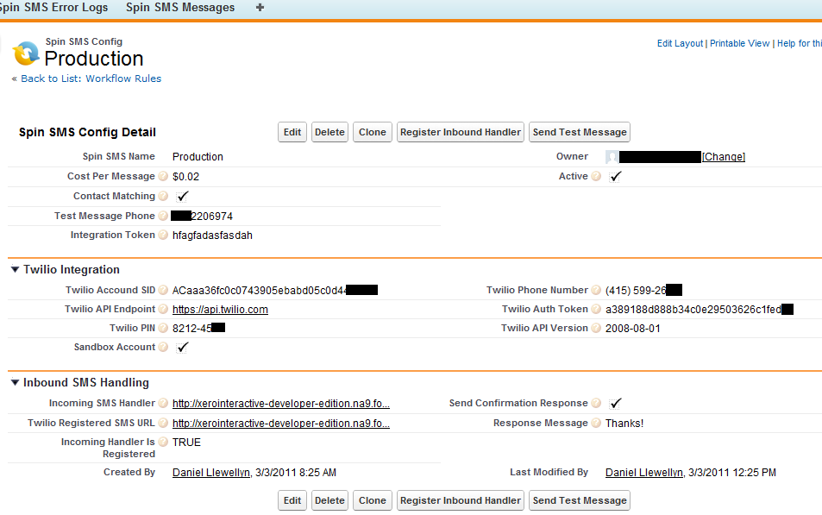

1. Send a test Message
   1. Log into Salesforce
   2. Navigate to your created SpinSMS config object
   3. Click the ‘Send Test Message’ button (You may need to add it to the page layout if it is not visible)
   4. The phone number specified ‘Test Message Phone’ field should receive a text message shortly.
      1. Remember, for Twilio Sandbox accounts, the number specified must be registered in Twilio
      2. The Test Message Phone field should contain a full phone number, no spaces or special characters.
2. Setup desired rules and actions
   1. You are now ready to begin using SpinSMS.
   2. If you require inbound message handling please see the section below “How to configure the inbound message handling system”
   3. To send SMS messages as a result of workflow rules, see the “How to configure the email services handler for SMS message sending” section.
   4. For more information or other implementation ideas, please see the usage guide.

**How to configure the email services handler for SMS message sending.**

A common use case is to send SMS messages as a result of some workflow rule. SpinSMS allows for this by use of email services. What happens is a workflow rule causes an email alert to a special email account that is monitored by a program. That program reads the contents of messages sent to the email address, extracts the data contained within the email and uses to create a SpinSMS message record. Once that record is created it is sent to Twilio. To enable this process you must create an email service and associated email address. Then create special email templates to be used by the workflow rules that will contain the phone number and message. Then set up your workflow rule to send the email to the email service program. SpinSMS takes care of the rest.

1. Create email service and associated email address – Email bot responsible for receiving message creation requests and creating new SMS message Records
   1. Log into Salesforce
   2. Navigate to setup->Develop->Email Services
   3. Create a new email service
   4. Enter a name for your service
   5. Choose the SpinSMS apex class
   6. Configure Failure response settings as desired
   7. Enable error routing, provide an email address you have access to
   8. Create an email address to associate with this service (EX: SpinSMS)

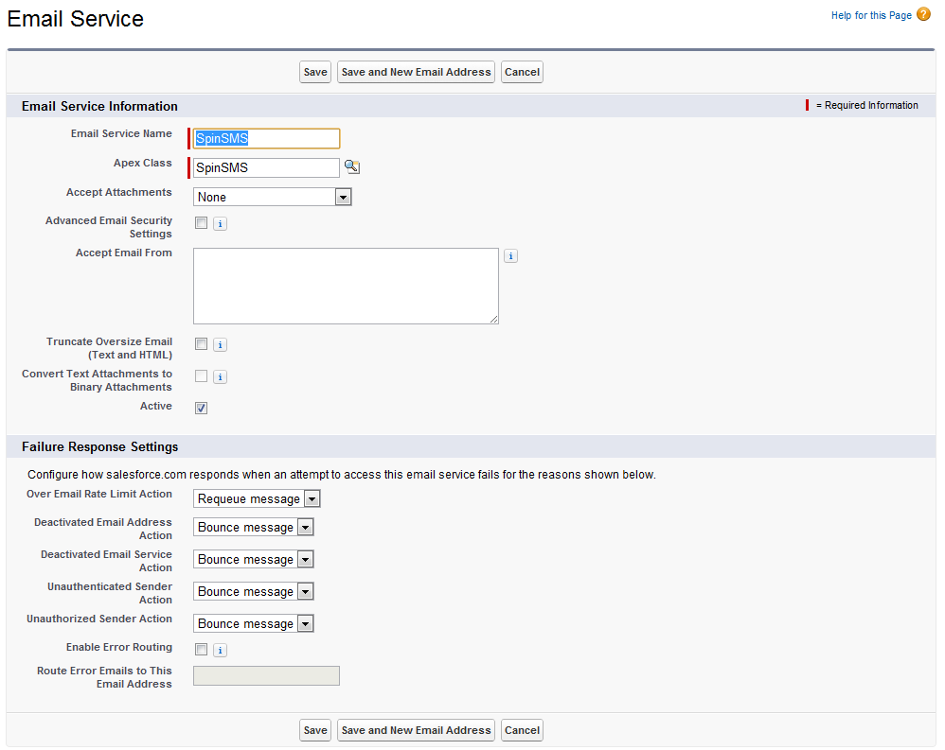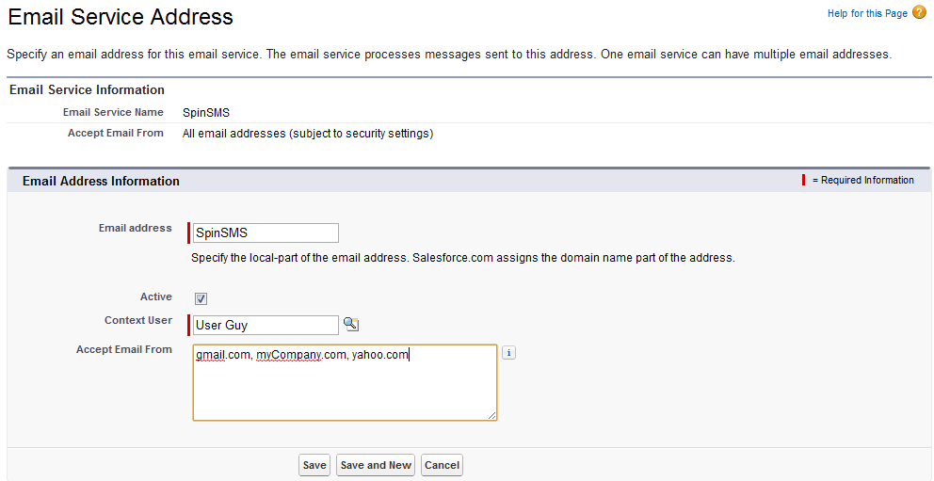

  
  
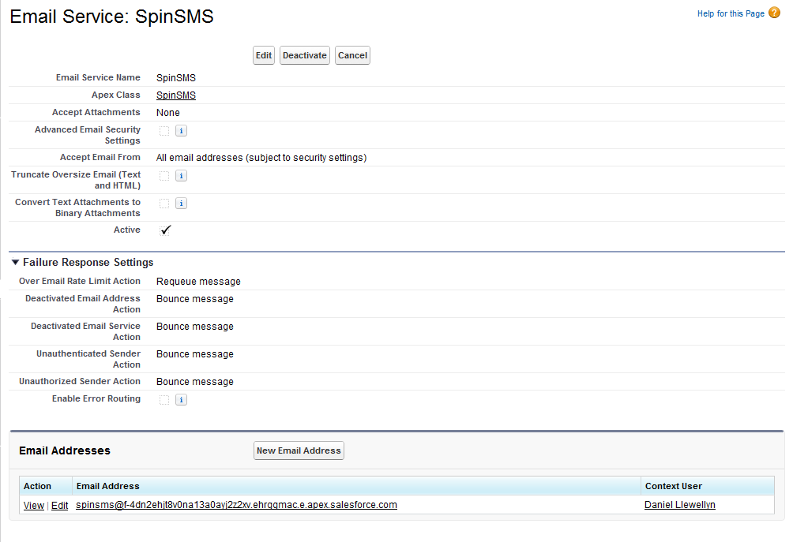

1. **\*** Create default SMS email template – Email templates contain the data used to send the SMS messages.
   1. Log into Salesforce
   2. Navigate to setup->Communication templates
   3. Create a new email template to use
   4. Copy and paste the contents of the exampleEmailTemplate.txt
   5. Make required changes to the data portions. Do not alter the XML structure of the message.

NOTE: You can create as many email templates as you like and use them for different workflow rules. Just copy the sample and change the defaults as needed.

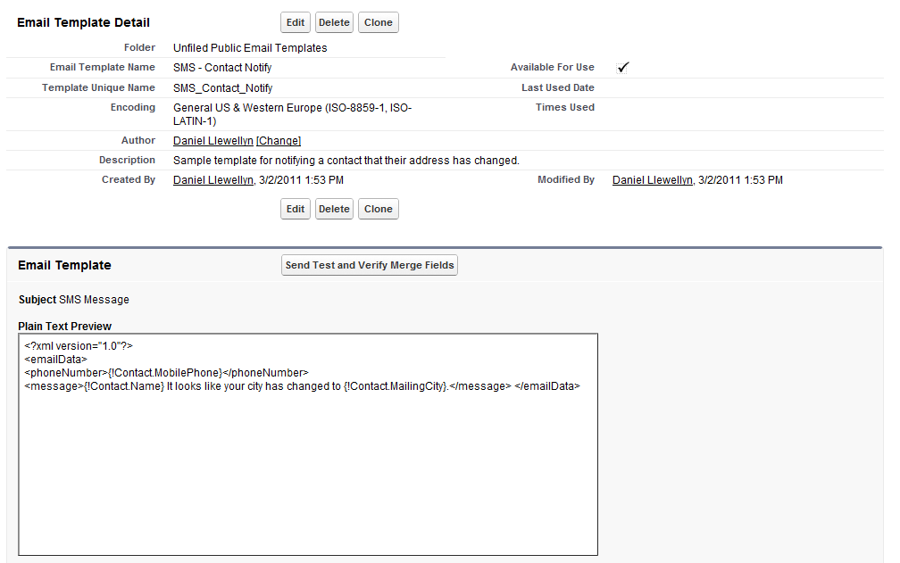

1. Create workflow rules that send the created email template to the email services address
   1. Log into Salesforce
   2. Navigate to setup->Create->Workflow Rules->Workflow rules
   3. Create new workflow rule related to whatever object you require (example pictured below)
   4. Set the conditions on the workflow rule that will cause it to trigger
   5. Add a new workflow action of “Email Alert”
   6. Specify the email template created above for the email template.
   7. Specify the email address of the email services bot created above as an ’additional to’ address.
   8. Save and activate the rule.

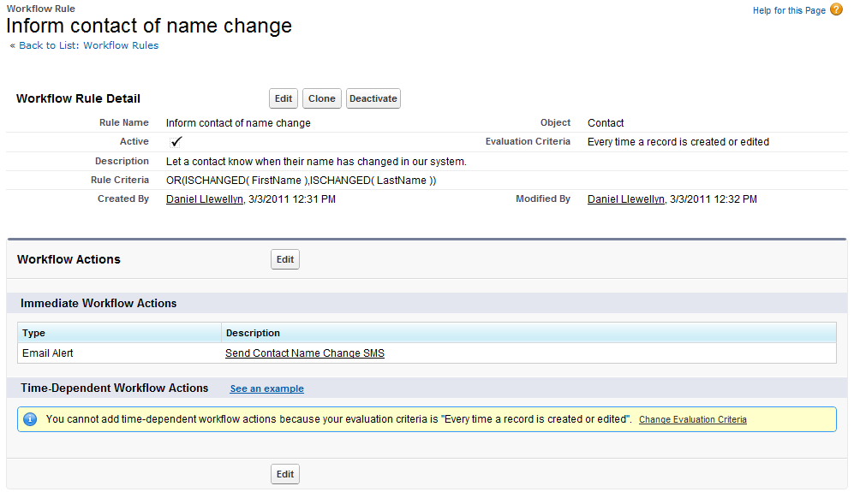

**How to configure the inbound message handling system**

If you want to allow users to reply to the messages you send, or even send you messages unsolicited you must have an inbound handler. When a person sends a text message to your Twilio phone number, Twilio will pass that information along to a URL you specify. The idea is that that URL can take the information and do something with it. SpinSMS is set up to take that information passed by Twilio and create an SMS message record. To do that, we need to have a publically available web page that Twilio can access. This is accomplished using Salesforce sites. The site hosts an included visualforce page which performs the actions outlined above. Once the site is set up, you then need to tell Twilio that that URL is where you want it to send the information.

1. Create SMS Force.com site – Twilio needs a place to send inbound SMS messages, this site listens, accepts and logs inbound SMS messages. Required only for inbound messages.
   1. Log into Salesforce
   2. Navigate to setup->Develop->Sites
   3. Create a new Site
   4. Choose a name and label. This site will only be used by Twilio to send inbound messages to
   5. Save the site

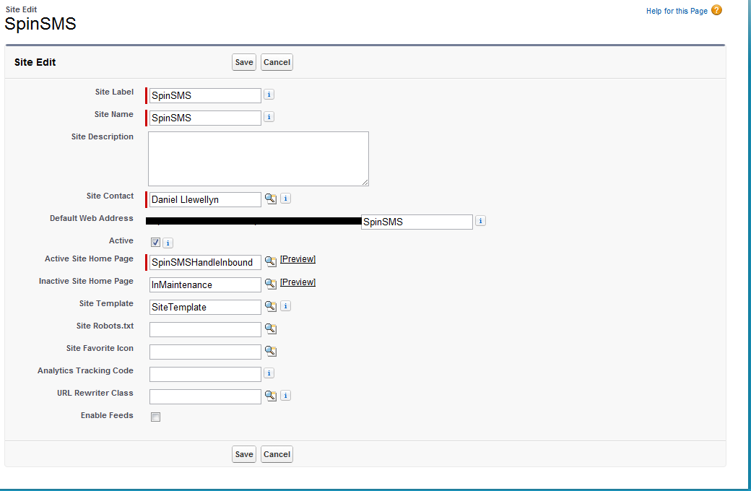

1. Modify the site user permissions – Enable the site user to access the needed resources for message creation. Required only for inbound messages.
   1. Log into Salesforce
   2. Navigate to setup->Develop->Sites
   3. Click the site label of your site that will handle inbound SMS messages
   4. Click public access settings
   5. Click edit
   6. Check all boxes related to Spin SMS Config, Spin SMS Message, and Spin SMS log as well as read from contacts.
   7. Save the changes

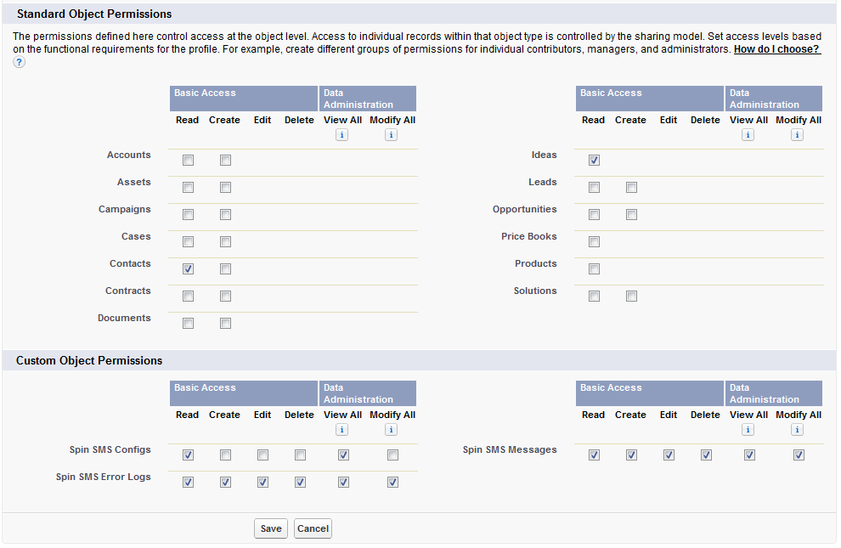

1. Enabled required Apex Classes and Pages – Enable the site user to access the Apex and Visualforce components needed for message creation. Required only for inbound messages.
   1. Log into Salesforce
   2. Navigate to setup->Develop->Sites
   3. Click the site label of your site that will handle inbound SMS messages
   4. Click public access settings
   5. Click edit next to ‘Enabled Apex Classes’
   6. Enable both JsonObject and SpinSMS apex classes
   7. Save
   8. Click edit next to ‘Enabled Visualforce Pages’
   9. Enable SpinSMSHandleInbound
   10. Save

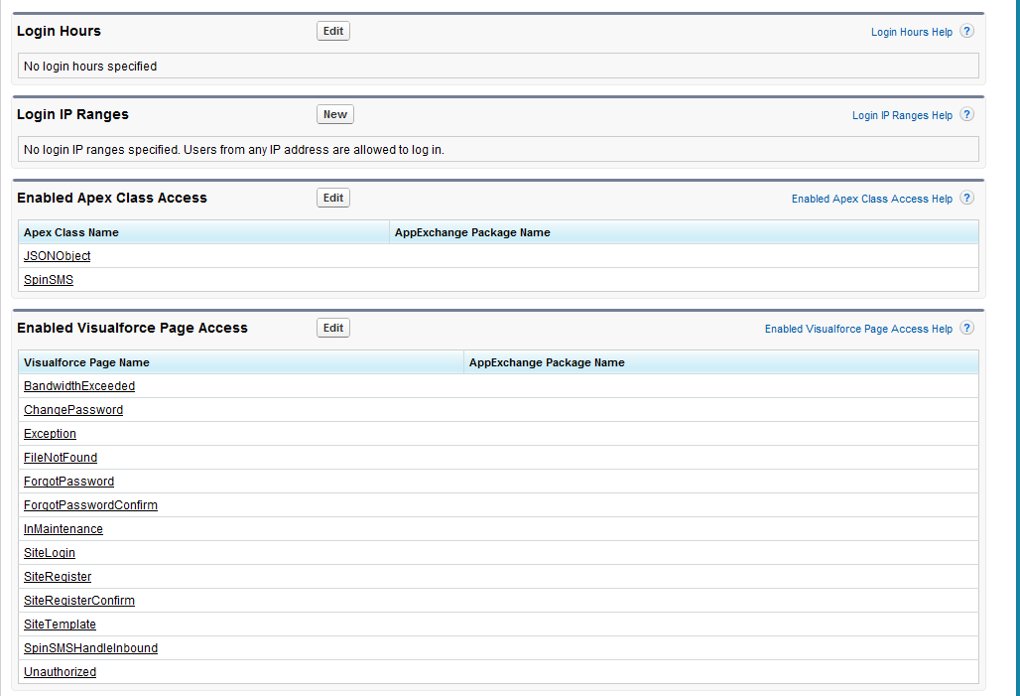

1. **\*** Create Inbound message handler page – This is the page directly responsible for accepting an inbound message and logging it.
   1. Log into Salesforce
   2. Navigate to setup->Develop->Pages
   3. Create a new page
      1. Label: SpinSMSHandleInbound
      2. Name: SpinSMSHandleInbound
   4. Copy and paste the content of SpinSMSHandleInbound.page file
2. Click the “Register Inbound Handler” button on the config object – Tells Twilio where to send Inbound message data, this case, your visualforce page.
   1. Log into Salesforce
   2. Navigate to your created SpinSMS config object.
   3. Ensure that the value entered for ‘Incoming SMS Handler’ is the url the SpinSMSHandleInbound page is available at
   4. Click the “Register Inbound Handler”
   5. Validate that the ‘Twilio Registered SMS URL’ value matches your ‘Incoming SMS handler’ value and that the ‘Incoming Handler Is Registered’ is TRUE